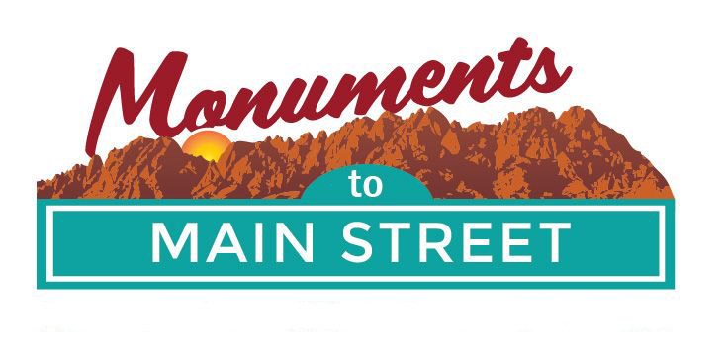

Monuments to Main Street Plein Air Competition

2018 Rules and Guidelines

The following items must be agreed to for participation in the 2018
Monuments to Main Street Plein Air Competition.

- Authentication stamp must be visible on the back of the artwork. The entire back of the entry must be visible at submission.
- Entries must be created in the pure intent of outdoor, on location, plein air painting. At least 75% of the painting must be produced outdoors in the spirit of plein air. The approved locations to paint include anywhere within Doña Ana county.
- Entries produced using manipulated photographic processes, computer enhanced imagery or other non-plein air means will not be accepted.
- Only one stamped painting media per artist may be entered into the competition. You can have as many pieces as you want stamped. However, only one can be entered for judging.
- Artist name, artwork title, and date should be legibly printed on
the back of submitted artwork.
- All media must be presented, ready for hanging. Choose the method that is most comfortable for you and will meets the display requirements. The maximum size of the artwork should not exceed 16” X20”. Framing is not required.
- If you are concerned about the protection and integrity of your submitted piece, we recommend you put it under glass or plexi-glass for protection. Please sign your piece in the bottom right hand corner of the canvass. It will be covered for judging. You are not required to sign your piece.
- Registration takes place on Wednesday, September 26th from 9am to noon at the Las Cruces Green Chamber Office, 221 N. Main Street. (Our office is down the hallway from M.Phillips Gallery, and about 5 feet from Julie Ford Oliver’s studio). Registration payment will be taken at that time in the form of cash, credit card, or check. Payment must accompany a completed registration form. Checks must be made out to: Las Cruces Green Chamber of Commerce.
- If you want to sell your piece, please indicate when you turn in your submission on September 29th for judging. Checks for the sale of any artwork will mailed after the 29^{h} of September.
- You will have from September 26th through September 29th to paint anywhere in designated areas (Monuments to Main Street is the theme).
- On Saturday, September 29th, you will need to turn in the one piece for judging between 8:30am and 10 am at the offices of the Dona Ana Arts Council, 1740 Calle de Mercado, Mesilla. Judging will take place at 11am. Awards will be announced at noon.
- You will be able to claim your artwork between 12:30 and 1pm. Any artwork that is not picked up by 1:00pm on September 29th becomes property of the plein air organizers.
- Winners of the 2018 plein air competition agree to the unlimited future use of their images in any of the Monuments to Main Street Plein air competition publicity (website, posters, advertisements, etc.).
- Awards for 1st, 2nd, and 3rd place will be given in each category (Professional, College, and Junior).
- PRE-Registration can be done up to the September 26th. You must visit the Las Cruces Green Chamber offices (address below) and submit payment and registration form in order to receive the pre-registration rate. If you pre-register, you will receive $5 off of your fee.
- Registered artists agree to respect both private property owners by securing permission to go onto their property and public lands. This means following the use regulations of the various land management agencies (i.e. staying on designated roads and trails, being respectful of private property, not removing any items, plants, animals from monument areas, etc.). If you have questions about this, please ask the plein air organizers.

Artists will be asked to confirm that the above rules and guidelines were followed when artwork was submitted for the competition.

For more information, contact Carrie Hamblen, CEO/President of the Las Cruces Green Chamber of Commerce at 575-323-1575 or carrie@locallascruces.com

