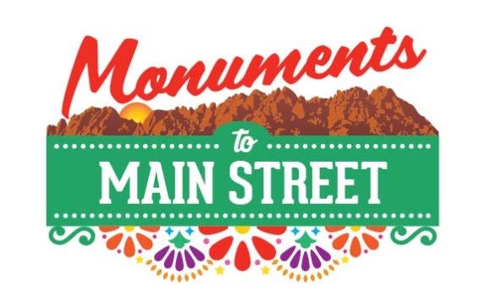

Registration for the 2018 Monuments to Main Street Plein Air Competition
Thank you for planning on joining us for the 3rd annual Monuments to Main Street Plein Air Competition. We look forward to having you participate!
Prior to registering, please review the Artists Rules and Guidelines. You will be asked to sign this form when you have your surfaces stamped at registration on Wednesday, September 26th from 9am to noon at the Las Cruces Green Chamber of Commerce office, 221 N. Main Street. If you cannot come at this time, please make arrangements with Carrie. Her contact information is at the end of this form.

Registration Fees

Professional: $30

College Students: $15 (current NMSU/DACC or other college id required at time of registration. OR, above the age of 18).

Student: $10 (ages 12-18)
$5 Early bird discount – Now through September 25th
Your registration fee will be discounted $5 if you register by COB on Tuesday, September 25th. You must contact the Green Chamber Offices to arrange payment and pre-registration at 575-323-1575. You can mail your form and payment to: Las Cruces Green Chamber of Commerce. 221 N. Main Street, Las Cruces, NM 88004.
Refunds will not be provided, although you may use your registration the following year should an unforeseen event cause you to cancel.

Registration Instructions
- Complete the form on the following page.
- Turn in completed form and payment at the Las Cruces Green Chamber office, 221 N. Main Street, NO LATER than Wednesday, September 26th between 9am and noon. Early Bird Registration must be received by September 25th. Checks should be made out to: Las Cruces Green Chamber of Commerce
- Please read the Instructions and Guidelines prior to registering. You will be asked to sign an acknowledgment form at the time of registration.

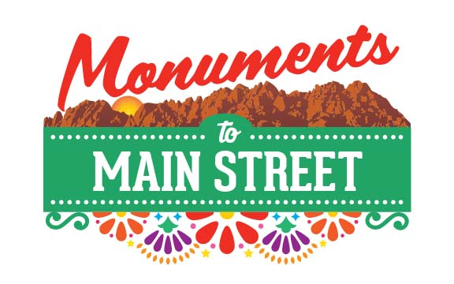

2018 Monuments to Main Street Plein Air Competition Registration Form

(One entry form per participant)

Name: ____________________________________________________

Address: ___________________________________________________

__________________________________________________________

Phone Number: ____________________________________________

Email:_____________________________________________________

Category:

Regular fee Early Bird fee
- Professional $30 $25
- College Student $15 $10
- Student $10 $5

Is your piece available for sale on the 29th? Yes No

If yes, one of two things can happen:
- We mail your purchase check to you at the address on this form OR
- That you pick up your check by 1pm on September 29th.

Any questions? Contact the Green Chamber offices at 575-323-1575 or carrie@locallascruces.com

